Name: Chetan Prajapat

College: Sage University Indore

Project Option Chosen:
Project Option 1 – Travel Itinerary Generator

GitHub Repository Link:
https://github.com/grchetan/Travel-Itinerary-Generator.git
Live Project URL (GitHub Pages):
https://grchetan.github.io/Travel-Itinerary-Generator

Project Type:
AI-Assisted Frontend + Automation Project
Video Link: https://drive.google.com/file/d/1ajS0px1dX5-MvT0OmMuyIz4xXiwp9Rrl/view?usp=drive_link
Technologies Used:
HTML, CSS, JavaScript, Cursor AI, n8n, LLM, GitHub Pages

Problem Statement
Planning a trip involves many factors such as destination, duration, budget, travel mode, and preferences.
Manually creating a structured travel itinerary is time-consuming and inconsistent.
Objective:
To build a system that collects user travel details, generates a personalized itinerary using AI, and sends it automatically to the user’s email.
Project Overview (What I Built)
I built a Travel Itinerary Generator web application that:
- Takes travel details from the user
- Validates inputs on the frontend
- Sends data to an automation workflow
- Uses AI to generate a personalized itinerary
- Sends the itinerary to the user’s email automatically

Technologies Used
Frontend
- HTML5
- CSS3
- JavaScript
AI & Automation
- Cursor AI (ASK mode)
- n8n (workflow automation)
- Large Language Model (LLM)
Deployment
- GitHub Pages

Frontend Web Application
Features Implemented
- Responsive design (mobile + desktop)
- Travel input form
- Client-side validation
- Error and feedback messages
- Hosted on GitHub Pages

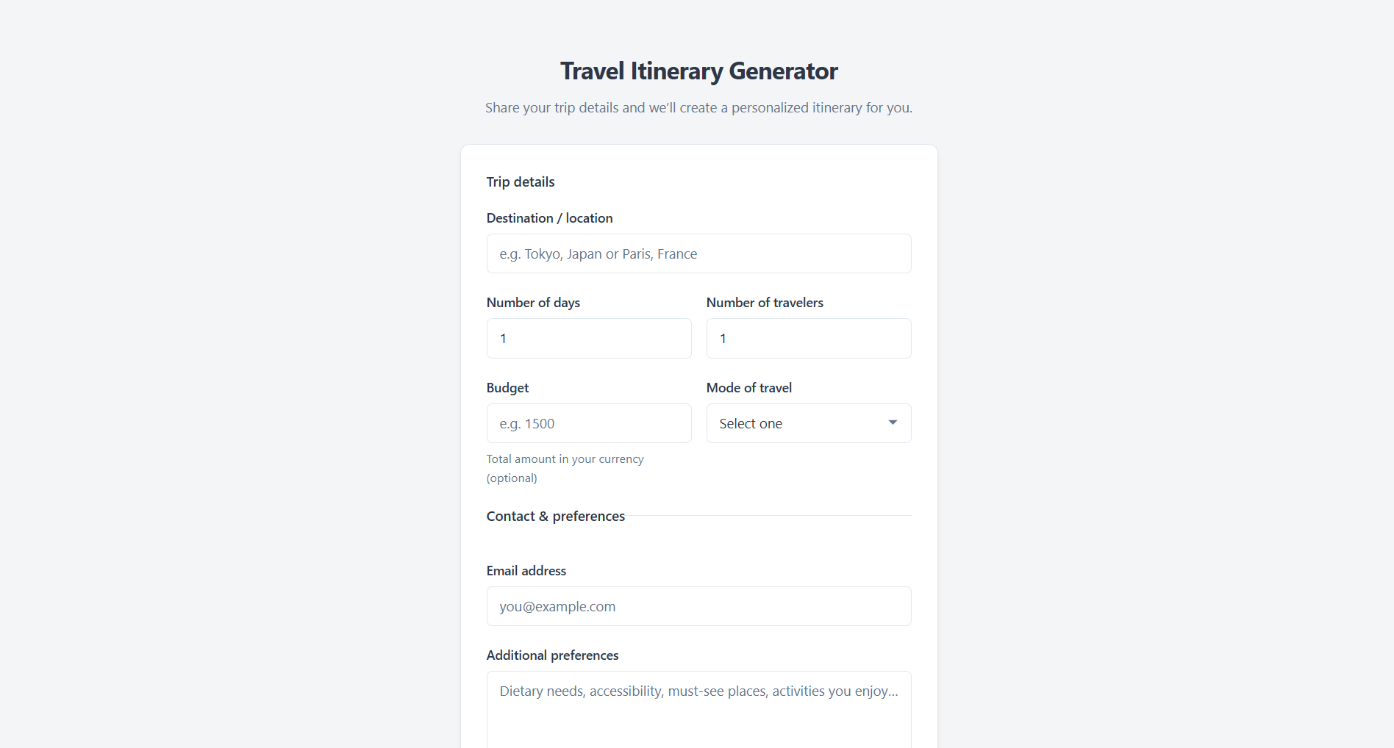

Automation Workflow (n8n)
Workflow Description
- Webhook receives form data
- Data stored in Google Sheets
- AI model generates itinerary
- Merge node combines email + AI output
- Gmail node sends itinerary to user

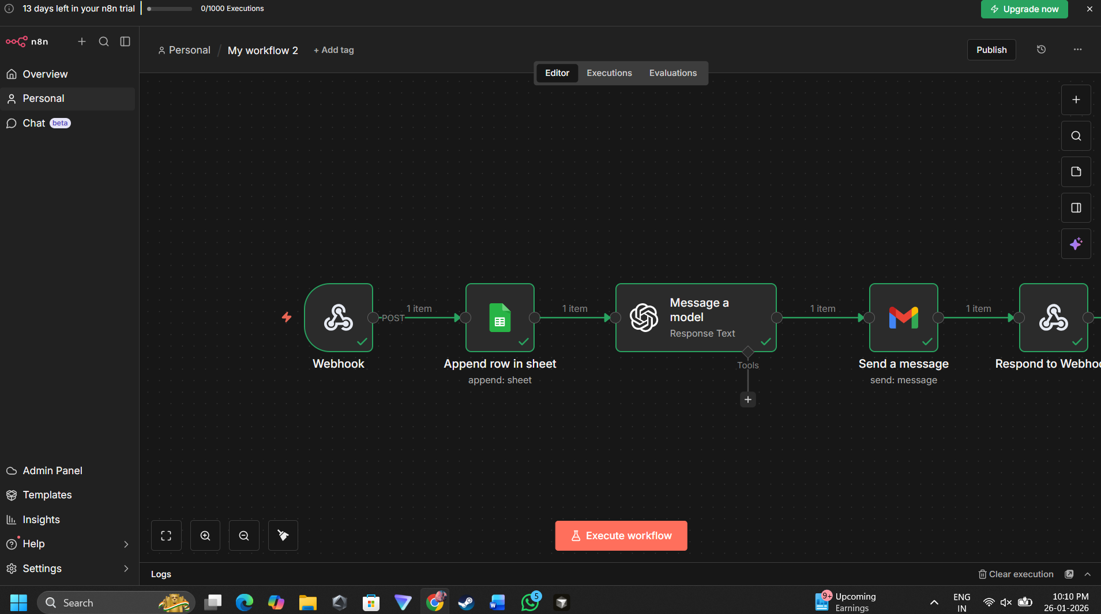

AI Integration (Responsible Use)
- AI used only to generate itinerary content
- Prompts written manually
- Output controlled and structured
- Developer reviewed and understood all outputs
- Cursor AI used as guidance, not direct copy

Email Automation Result
After successful submission:
- User receives itinerary on the same email they entered
- Email is clean, professional, and readable
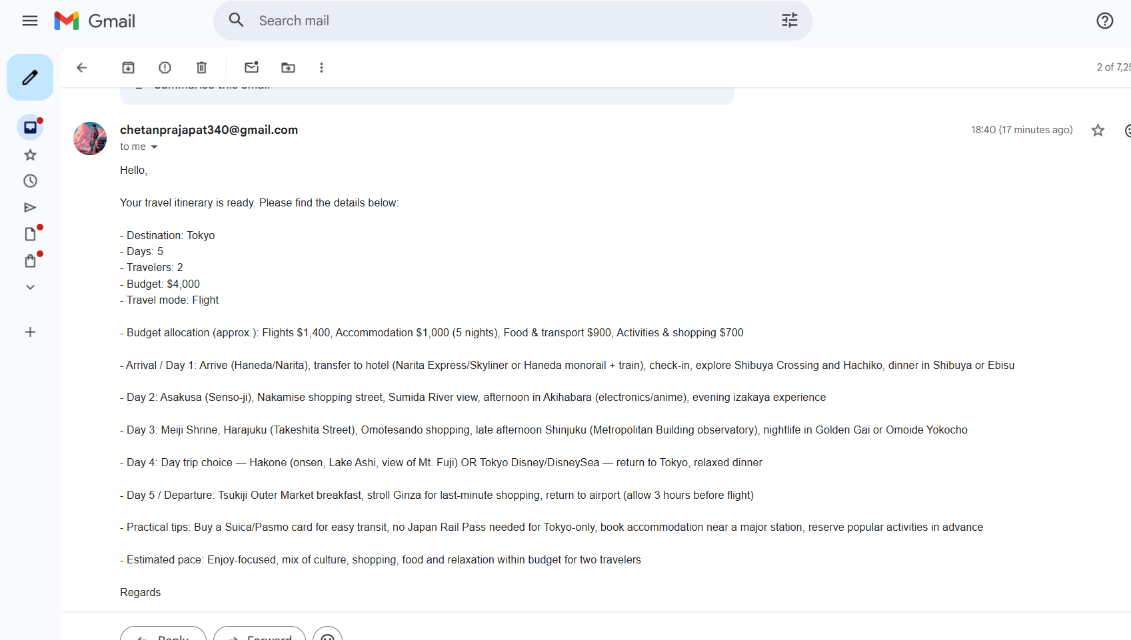

Hosting & Deployment
The frontend is hosted using GitHub Pages, making it accessible online.
